How to AND, OR, XOR, NAND, etc. all bits of a signal in VHDL

Created by: David Rubio G.
Blog: https://soceame.wordpress.com/
GitHub: https://github.com/DRubioG
Last modification date: 04/03/25

A very common situation is when you want to perform a binary operation on a multi-bit signal in VHDL, such as an OR or an AND of all the bits of a signal (or part of it).
The general method is to resort to performing the operation bit by bit, which can leave parts of the code quite long. E.g.:
a <= "001010";

b <= a(5) or a(4) or a(3) or a(2) or a(1) or a(0);
c <= a(5) and a(4) and a(3) and a(2) and a(1) and a(0);
Another option is to use a for loop with a variable (but this can make development very complex, because the variables must be initialized to avoid errors):
variable b_aux, c_aux : std_logic_vector(5 downto 0);
begin
...
for i in a'range loop
b_aux := b_aux or a(i);
c_aux := c_aux and a(i);
end loop;
...

Solution
Well, to solve this situation, there is a library called "std_logic_misc" with several functions that perform these calculations.
To use this library you have to load the library at the beginning:
library ieee;
use ieee.std_logic_1164.all;
use ieee.std_logic_misc.all;
And with this library loaded, the following functions can be used:
- or_reduce(<std_logic_vector>): This function ORs all the bits of the std_logic_vector signal and returns a 1-bit std_logic value.
- and_reduce(<std_logic_vector>): This function ANDs all the bits of the std_logic_vector signal and returns a 1-bit std_logic value.
- nand_reduce(<std_logic_vector>): This function NANDs all the bits of the std_logic_vector signal and returns a 1-bit std_logic value.
- nor_reduce(<std_logic_vector>): This function NORs all the bits of the std_logic_vector signal and returns a 1-bit std_logic value.
- xor_reduce(<std_logic_vector>): This function XORs all the bits in the std_logic_vector signal and returns a 1-bit std_logic value.
- xnor_reduce(<std_logic_vector>): This function XNORs all the bits in the std_logic_vector signal and returns a 1-bit std_logic value.
An example of using these functions
library ieee;
use ieee.std_logic_1164.all;
use ieee.std_logic_misc.all;

entity test is
port(
a : in std_logic_vector(4 downto 0);
c, d, e, f, g, h : out std_logic
);
end entity;

architecture arch_test of test is

begin

c <= or_reduce(a);
d <= and_reduce(a);
e <= xor_reduce(a);
f <= nand_reduce(a);
g <= xnor_reduce(a);
h <= nor_reduce(a);

end architecture;
The functions generate an RTL model like the following
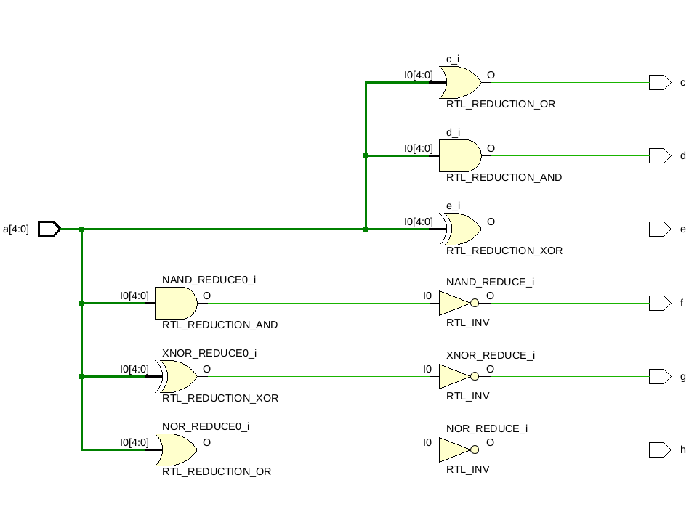
And a synthesis model like the following
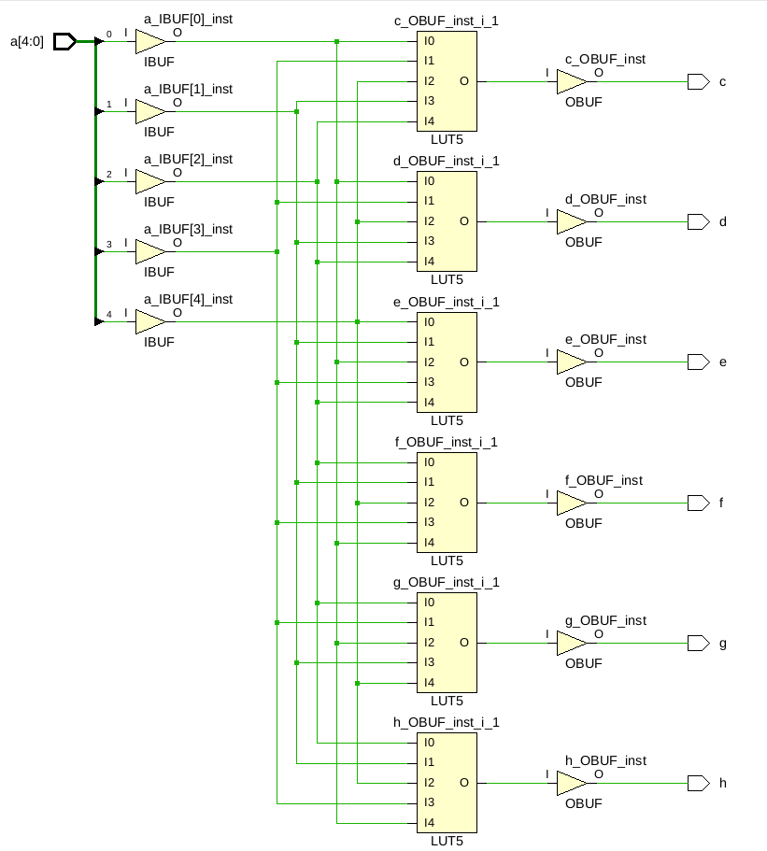

NOTE
The 2008 VHDL standard supports a new, simpler way of doing the above, without resorting to the 'std_logic_misc' library, and that is to use the word logic before the signal/port. Example:
library ieee;
use ieee.std_logic_1164.all;
use ieee.std_logic_misc.all;
entity borrar is
port(
a : in std_logic_vector(4 downto 0);
c, d, e, f, g, h : out std_logic
);
end entity;
architecture arch_borrar of borrar is
begin
c <= or a;
d <= and a;
e <= xor a;
f <= nand a;
g <= xnor a;
h <= nor a;

end architecture;

